# **Test Plan (OrangeHRM.com)**

**Test Plan** **1**

Objective 2

Scope 2

Inclusions 4

Test Environments 6

Defect Reporting Procedure 7

Test Strategy 8

Test Schedule 9

Test Deliverables. 10

Entry and Exit Criteria 10

Entry Criteria: 10

Exit Criteria: 11

Test Execution 11

Entry Criteria: 11

Exit Criteria: 11

Test Closure 11

Entry Criteria: 11

Exit Criteria: 11

Tools 11

Risks and Mitigations 11

Approvals 12

#### 

## 

## Objective

The objective of this manual testing test plan for OrangeHRM is to ensure the comprehensive evaluation of the software's functionality, usability, and reliability. By meticulously testing various aspects of the system, we aim to identify and report any defects, discrepancies, or areas for improvements , ensuring that OrangeHRM operates efficiently and effectively for end-users. This test plan will help guarantee that the software meets the specified requirements and performs reliably in a real-world environment, ultimately contributing to a seamless and productive user experience.

## Scope

**1. Features and Functionality to be Tested**

In this section, we will outline the key features and functionalities of OrangeHRM.com that will be tested during the software quality assurance process. Each feature or functionality will be described briefly for clarity.

**1.1 User Authentication and Access Control**

**Objective:** Verify secure and effective user authentication.

**Testing Focus:**

* Login functionality
* Role-based access control
* Password policies and account lockout mechanisms

**1.2 Employee Management**

**Objective:** Ensure accurate storage and display of employee information.

**Testing Focus:**

* Add, edit, and delete employee records
* Validation of employee data fields
* User role-specific access

**1.3 Recruitment and Onboarding**

**Objective:** Test job posting, application submission, and onboarding workflows.

**Testing Focus:**

* Job posting and application process
* Resume and candidate profile storage
* Onboarding workflow and documentation collection

**1.4 Time and Attendance Management**

**Objective:** Validate employee attendance tracking and timesheet accuracy.

**Testing Focus:**

* Clock-in/clock-out features
* Timesheet accuracy
* Leave request and approval processes

**1.5 Payroll and Compensation**

**Objective:** Verify accurate payroll calculations and payment processing.

**Testing Focus:**

* Payroll calculations, including taxes and deductions
* Payment processing and pay stub generation
* Compliance with tax and labor laws

**2. Types of Testing**

In this section, we will specify the various types of testing that will be conducted to ensure the quality and reliability of OrangeHRM.com. Each type of testing serves a specific purpose in evaluating different aspects of the software.

**2.1. Manual Testing:**

**Objective:** Evaluate the user interface, functionality, and usability of the application through manual interaction.

**Description:** Skilled testers will perform test cases manually to identify issues related to the user experience, navigation, and overall functionality. This includes exploratory testing to uncover unexpected defects.

**2.2. Performance Testing:**

**Objective:** Assess the system's responsiveness, scalability, and stability under various load conditions.

**Description:** Performance testing will be conducted to evaluate how the application performs under typical and peak loads. This includes load testing, stress testing, and scalability testing.

**2.3. Accessibility Testing:**

**Objective:** Ensure that the application is accessible to all users, including those with disabilities.

**Description:** Accessibility testing will be performed to validate compliance with accessibility standards (e.g., WCAG). This includes testing with assistive technologies and keyboard navigation.

**2.4. Security Testing:**

**Objective:** Identify vulnerabilities and ensure that sensitive data is protected.

**Description:** Security testing will focus on identifying security flaws, including but not limited to authentication, authorization, data encryption, and protection against common security threats (e.g., SQL injection, XSS).

**2.5. Compatibility Testing:**

**Objective:** Ensure that the application functions correctly on various platforms and browsers.

**Description:** Compatibility testing will involve testing on different web browsers, operating systems, and mobile devices to confirm consistent behavior and functionality.

**2.6. Usability Testing:**

**Objective:** Assess the overall user experience and ease of use of the application.

**Description:** Usability testing will involve real users who will provide feedback on the application's design, layout, and intuitiveness.

**2.7. Regression Testing:**

**Objective:** Confirm that new updates or changes do not adversely affect existing functionality.

**Description:** Regular regression testing will be performed, both manually and automated, to verify that changes do not introduce defects in previously working areas.

**2.8. Compliance and Regulatory Testing:**

**Objective:** Ensure compliance with relevant laws, regulations, and industry standards.

**Description:** Testing will focus on verifying adherence to specific legal and regulatory requirements, such as labor laws, data privacy regulations, and industry-specific standards.

**4. The Evaluation Criteria:**

In this section, we will define the criteria that will be used to assess the success and effectiveness of the manual testing process for OrangeHRM.com.

**4.1 Defect Metrics**

a. **Defect Count:** The number of defects identified during testing will be tracked, categorized, and reported. Defects will be classified based on severity and impact on functionality.

b. **Defect Closure Rate:** The rate at which identified defects are resolved and closed will be monitored. This includes tracking the time taken to fix and retest defects.

**4.2 Test Coverage**

a. **Test Coverage Percentage:** The extent of test coverage, including the percentage of functional requirements covered by test cases, will be assessed. We aim for comprehensive test coverage.

**4.3 Testing Efficiency**

a. **Testing Duration**: The time taken to complete the testing process, including preparation, execution, and reporting, will be recorded. Deviations from the planned schedule will be evaluated.

b. **Test Execution Speed**: The speed and efficiency of manual test case execution will be assessed to ensure timely and effective testing.

**4.4 User Satisfaction**

a. **User Feedback**: User satisfaction ratings and feedback will be collected through usability testing and surveys to gauge the application's ease of use and overall user experience.

**4.5 Risk Assessment**

a. **Risk Mitigation**: The effectiveness of risk mitigation strategies and the identification of critical defects will be evaluated.

**4.6 Test Documentation Completeness**

a. **Test Documentation:** The completeness and accuracy of test cases, test plans, and test reports will be reviewed to ensure that all testing activities are well-documented.

These evaluation criteria will be used to assess the success of the manual testing process and provide a clear measure of the quality and reliability of OrangeHRM.com. Regular reporting and analysis of these criteria will guide the testing process and facilitate continuous improvement.

**7.4 Subject Matter Experts (SMEs)**

* **Role:** SMEs have in-depth knowledge of HR processes and may be involved in testing HR-specific functionalities.
* **Responsibilities:**
  + Review and validate HR-related test cases.
  + Provide domain expertise to ensure that HR-specific requirements are met.
  + Collaborate with testers to clarify test scenarios and expected outcomes.

**7.5 Stakeholders**

* **Role:** Stakeholders represent end-users, product owners, and decision-makers.
* **Responsibilities:**
  + Provide input on testing priorities and requirements.

Review and approve test plans, if required.

* + Participate in usability testing and provide feedback on the user experience.
  + Review and accept the final testing results.

**8. Schedule and Milestones**

In this section, we will provide a detailed schedule for the manual testing process, including the start and end dates, along with planned testing activities and key milestones.

**8.1 Testing Timeline**

* Start Date: [Insert Start Date]
* End Date: [Insert End Date]

**8.2 Testing Activities**

Below is a breakdown of the planned testing activities and their respective milestones:

**Milestone 1: Test Planning and Preparation (Week 1 - Week 2)**

* **Week 1 (Start Date - End Date)**
  + Define the scope of testing.
  + Develop the test plan and strategy.
  + Identify and allocate resources.
  + Prepare test environments.
* **Week 2 (Start Date - End Date)**
  + Create detailed test cases based on requirements.
  + Review and finalize test documentation.
  + Conduct a kickoff meeting with the testing team.
  + The tools and equipment that will be used for testing, such as testing software, hardware, and documentation templates.

**Milestone 2: Functional Testing (Week 3 - Week 4)**

* **Week 3 (Start Date - End Date)**
  + Execute test cases related to user authentication and access control.
  + Begin testing employee management features.
* **Week 4 (Start Date - End Date)**
  + Continue testing employee management, including recruitment and onboarding.
  + Start testing time and attendance management features.

**Milestone 3: Performance and Compatibility Testing (Week 5 - Week 6)**

* **Week 5 (Start Date - End Date)**
  + Conduct performance testing, including load and stress testing.
  + Test on various browsers and operating systems.
* **Week 6 (Start Date - End Date)**
  + Continue compatibility testing on different devices and screen sizes.
  + Begin accessibility testing.

**Milestone 4: Security and Usability Testing (Week 7 - Week 8)**

* **Week 7 (Start Date - End Date)**
  + Perform security testing, including vulnerability assessment.
  + Start usability testing to gather user feedback.
* **Week 8 (Start Date - End Date)**
  + Continue usability testing and incorporate user feedback.
  + Perform regression testing to ensure defect fixes did not introduce new issues.

**Milestone 5: Reporting and Closure (Week 9 - Week 10)**

* **Week 9 (Start Date - End Date)**
  + Generate and review test reports.
  + Address any outstanding defects.
  + Conduct a review meeting with stakeholders.
* **Week 10 (Start Date - End Date)**
  + Obtain final acceptance from stakeholders.
  + Prepare the final test report for documentation.
  + Complete the testing process.

**8.3 Contingency and Buffer Time**

* Buffer time has been allocated within each milestone to accommodate unforeseen issues, additional testing, or retesting activities.
* The total buffer time allocated is [13-14] weeks.

# Inclusions

**Test Objectives** The primary objective of the testing process is to systematically identify, document, and address defects, errors, or inconsistencies in the software. Testers will execute test cases with the goal of uncovering defects in the software's functionality, usability, security, or performance. The objective is to enhance the software's reliability and quality by eliminating defects that could impact its functionality or user experience.

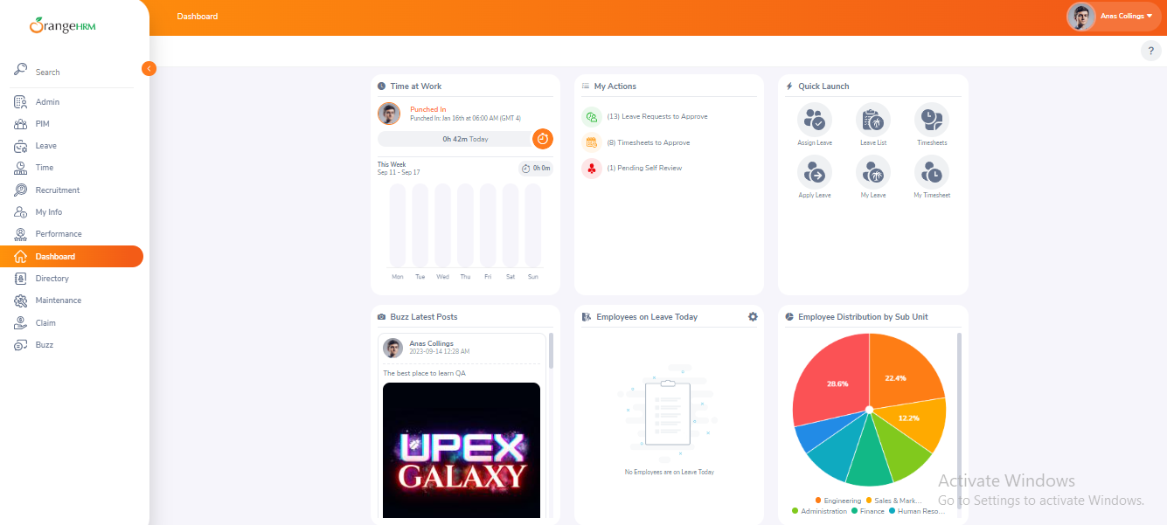

### Test Environments

In this section, we will outline the various environments in which manual testing for OrangeHRM.com will be conducted. Ensuring compatibility across different browsers, operating systems, and device types is essential to guarantee a seamless user experience.

**3.1 Browser**

Manual testing will be performed on the following web browsers to verify cross-browser compatibility:

a. Google Chrome (latest version)

b. Mozilla Firefox (latest version)

c. Microsoft Edge (latest version)

d. Apple Safari (latest version)

e. Opera (latest version)

**3.2. Operating System**

Manual testing will be conducted on different operating systems to ensure consistent functionality and appearance:

a. Windows 10

b. macOS Big Sur (or the latest version available)

c. Ubuntu Linux (latest LTS release)

**3.3 Mobile Devices**

Testing on various mobile devices is crucial to verify mobile responsiveness and functionality. Manual testing will include:

a. Apple iPhone (iOS) - latest models (e.g., iPhone 13, iPhone 12)

b. Android smartphones - latest models (e.g., Samsung Galaxy S21, Google Pixel 6)

c. Apple iPad (iOS) - latest models

d. Android tablets - latest models

**3.4 Screen Sizes and Resolutions**

To ensure responsive design and layout compatibility, testing will cover a range of screen sizes and resolutions, including but not limited to:

a. Desktop monitors with various resolutions (e.g., 1920x1080, 2560x1440)

b. Laptop screens (e.g., 1366x768, 1920x1080)

c. Mobile phone screens with different sizes (e.g., 5.5 inches, 6.5 inches)

d. Tablet screens (e.g., 9.7 inches, 10.5 inches)

The access permissions and roles of the team members who will be using the test environment, such as testers, developers, or stakeholders.

|  |  |
| --- | --- |
| **Name** | **Env url** |
| QA | qa.OrangeHRM.com |
| Pre Prod | preprod.OrangeHRM.com |
| UAT | uat.OrangeHRM.com |
| Prod | app.OrangeHRM.com |

### **Defect Reporting Procedure**

**1. Criteria for Identifying Defects:**

* **Deviation from Functional Requirements:** Defects occur when the software doesn't match specified functionality.
* **User Experience Issues:** Defects include usability problems affecting the user interface and experience.
* **Technical Errors:** Defects involve technical issues like crashes, errors, or unexpected behavior.
* **Security Vulnerabilities:** Defects include security weaknesses or data protection failures.
* **Compatibility Issues:** Defects occur when the software doesn't work consistently across different platforms.

**2. Steps for Reporting a Defect:**

* Use a designated defect reporting template or system.
* Provide essential defect details, including title, description, reproduction steps, expected outcome, and actual outcome.
* Attach supporting evidence, such as screenshots, logs, and environment information.
* Assign severity and priority levels to the defect.
* Submit the defect report through the designated system.
* Monitor the defect's status and communicate with the development team as needed.
* Verify the resolution once the defect is fixed by retesting it.

**3. A**[**bug triage**](https://www.guru99.com/bug-defect-triage.html)**is a process to**

* Ensure bug report completeness
* Assign and analyze the bug
* Assigning bug to proper bug owner
* Adjust bug severity properly
* Set appropriate bug priority

**4.Testing Tools**

To support testing during development of application following tools can be used

* Test Management Tools: JIRA, Quality Center etc.
* Defect Management Tools: Test Director, Bugzilla
* Project Management Tools: Sharepoint
* Automation Tools: RFT, QTP, and WinRunner

**5. Roles and Responsibility:**

In this section, we will outline the roles and responsibilities of team members involved in the manual testing process for OrangeHRM.com. Clear roles and responsibilities ensure efficient and organized testing efforts.

**5.1 Test Lead**

* **Role:** The Test Lead will oversee the entire manual testing process and ensure that it aligns with the testing strategy and objectives.
* **Responsibilities:**
  + Develop the overall test plan and strategy.
  + Define test objectives, scope, and priorities.
  + Assign test cases to testers and coordinate testing activities.
  + Monitor progress, track defects, and report on testing status.
  + Communicate with stakeholders and manage their expectations.
  + Ensure that test documentation is complete and accurate.
  + Review and approve test cases and test reports.
  + Collaborate with developers to resolve critical defects.

**5.2 Testers**

* **Role:** Testers will execute manual test cases and thoroughly evaluate the application for defects and usability issues.
* **Responsibilities:**
  + Execute test cases as per the test plan.
  + Report defects with detailed information, including steps to reproduce.
  + Perform exploratory testing to identify unexpected issues.
  + Verify fixes for reported defects.
  + Participate in test case review sessions.
  + Provide timely feedback to the Test Lead regarding testing progress and challenges.
  + Collaborate with developers to reproduce and clarify defects.

**5.3 Developers:**

* **Role**: Developers are responsible for addressing and resolving defects reported by testers.
* **Responsibilities:**
  + Review and analyze defect reports provided by testers.
  + Reproduce reported defects and investigate their root causes.
  + Prioritize and fix defects based on their severity and impact.
  + Collaborate with testers to ensure that defects are resolved satisfactorily.
  + Maintain clear communication with the Test Lead regarding defect resolution.
  + Participate in regression testing to ensure that defect fixes do not introduce new issues.

**6. Communication Channels:**

* **Defect Tracking System:** Real-time updates.
* **Status Meetings:** Daily stand-ups and weekly project meetings.
* **Email Updates:** Weekly summary emails.

**7. Metrics for Measuring Defect Reporting Effectiveness:**

**7.1 Number of Defects Found:**

* **Metric:** The total count of defects identified and reported during testing.
* **Objective:** To assess the thoroughness of defect detection efforts and overall software quality.

**7.2 Defect Resolution Time:**

* **Metric:** The average time taken to resolve defects, measured from the point of reporting to the closure of the defect.
* **Objective:** To gauge the efficiency of defect resolution and address delays promptly.

**7.3 Defect fix Rate:**

* **Metric:** The percentage of reported defects that were successfully fixed and closed.
* **Objective:** To measure the effectiveness of the development team in addressing reported issues.

**7.4 Defect Severity Distribution:**

* **Metric:** Categorization of defects by severity levels (e.g., low, medium, high, critical).
* **Objective:** To prioritize defect resolution efforts based on their impact on the software.

**Test Management Tools - JIRA**

### **8. Test Strategy**

The first step is to create test scenarios and test cases for the various features in

Scope.

While developing test cases, we'll use a number of test design techniques.

o Equivalence Class Partition

o Boundary Value Analysis

o Decision Table Testing

o State Transition Testing

o Use Case Testing

We also use our expertise in creating Test Cases by applying the below:

o Error Guessing

o Exploratory Testing

• We prioritize the Test Cases

**Step 2: Our testing procedure when we receive a request for testing:**

• First, we'll conduct smoke testing to see if the various and

important functionalities of the application are working.

• We reject the build, if the Smoke Testing fails and will wait for the stable

build before performing in depth testing of the application functionalities.

• Once we receive a stable build, which passes Smoke Testing, we perform

in depth testing using the Test Cases created.

• Multiple Test Resources will be testing the same Application on Multiple

Supported Environments simultaneously.

We then report the bugs in bug tracking tool and send dev. management

the defect found on that day in a status end of the day email.

As part of the Testing, we will perform the below types of Testing:

o Smoke Testing and Sanity Testing

o Regression Testing and Retesting

o Usability Testing, Functionality & UI Testing

• We repeat Test Cycles until we get the quality product.

**Step 3 – We will follow the below best practices to make our Testing better:**

• **Context Driven Testing** – We will be performing Testing as per the context

of the given application.

• **Shift Left Testing** – We will start testing from the beginning stages of the

development itself, instead of waiting for the stable build.

• **Exploratory Testing** – Using our expertise we will perform Exploratory

Testing, apart from the normal execution of the Test cases.

• **End to End Flow Testing** – We will test the end-to-end scenario which

involve multiple functionalities to simulate the end user flows.

### 9. Test Schedule

Following is the test schedule planned for the project –

Task Time Duration

|  |  |
| --- | --- |
| **Task** | **Dates** |
| ▪ Creating Test Plan |  |
| ▪ Test Case Creation |  |
| ▪ Test Case Execution |  |
| ▪ Summary Reports Submission Date |  |

**2 Sprints to Test the Application**

### **10. Test Deliverables.**

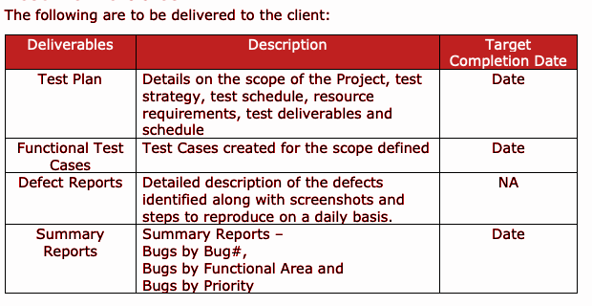

### **10. Entry and Exit Criteria**

The below are the entry and exit criteria for every phase of Software Testing Life

Cycle:

Requirement Analysis

#### **Entry Criteria:**

• Once the testing team receives the Requirements Documents or details

about the Project

#### **Exit Criteria:**

• List of Requirements are explored and understood by the Testing team

• Doubts are cleared

### **11. Test Execution**

#### **Entry Criteria:**

• Test Scenarios and Test Cases Documents are signed-off by the Client

• Application is ready for Testing

#### **Exit Criteria:**

• Test Case Reports, Defect Reports are ready

### **12. Test Closure**

#### **Entry Criteria:**

• Test Case Reports, Defect Reports are ready

#### **Exit Criteria:**

• Test Summary Reports

#### **13. Tools**

The following are the list of Tools we will be using in this Project:

• JIRA Bug Tracking Tool

• Mind map Tool

• Snipping Screenshot Tool

• Word and Excel documents

#### **14. Risks and Mitigations**

The following are the list of risks possible and the ways to mitigate them:

Risk: Non-Availability of a Resource

Mitigation: Backup Resource Planning

Risk: Build URL is not working

Mitigation: Resources will work on other tasks

Risk: Less time for Testing

Mitigation: Ramp up the resources based on the Client needs dynamically

#### 

#### **15. Approvals**

Team will send different types of documents for Client Approval like below:

• Test Plan

• Test Scenarios

• Test Cases

• Reports

Testing will only continue to the next steps once these approvals are done